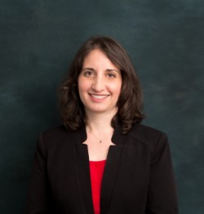

**Audra Lewton** is the Director of Planned Giving at The New York Community Trust, where she helps supporters create meaningful charitable legacies. An attorney with extensive experience in estate and philanthropic planning, she has counseled and collaborated with individuals, families, and charities on a wide range of matters.

Audra began her career as an associate in the private client group at Willkie Farr & Gallagher LLP. She then spent over a decade at Barnard College, where she served as Director of Gift and Estate Planning and Assistant General Counsel, before returning to private practice at Brick & Patel LLP, and later establishing her own law practice.

An active volunteer in her local community and a devoted team leader for the Lustgarten Foundation’s annual Long Island Walk for Pancreatic Cancer Research, she is also a member of the Board of Directors of the Philanthropic Planning Group of Greater New York and a member of the New York City Bar Association, having served on its Non-Profit Organizations Committee. Audra earned a B.A. *magna cum laude* in Political Science and French from Wellesley College and a J.D. *cum laude* from Cornell Law School and is admitted to practice law in New York State.